**Name: Samruddhi Shivarkar**

**Working with a Vi Editor:**

1: Create a file using vi. Enter the following text:

A network is a group of computers that can communicate with each other, share

resources, and access remote hosts or other networks. Netware is a computer network

operating system designed to connect, manage, and maintain a network and its

services. Some of the network services are Netware Directory Services (NDS), file

system, printing and security.

1. Change the word “Netware” in the second line to “Novell Netware”.

**Command in the Command Mode:**

**: %s/\<Netware\>/Novel Netware/g**

b. Insert the text “(as such hard disks and printers)” after “share resources” in the

first line.

**: s/share resources / share resources such hard disks and printers /**

c. Append the following text to the file:

“Managing NDS is a fundamental administrator role because NDS provides a single

point for accessing and managing most network resources.”

**Answer**

**1 Open the vim file**

**2. move to the end of the file using shift+G**

**3.press A to append to the end of the current line or O to open new line below current line**

**4. add the text or copy taste it five press escape to return and then save file using**

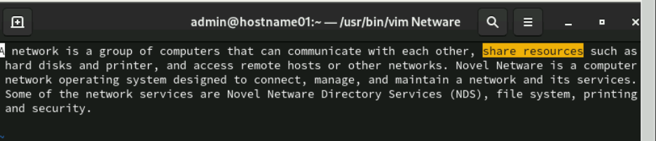

Working shell

1. Type some text on the shell separated by space

1: Move cursor one word back

Ans: **Control + left arrow or b in vim**

2: Move cursor one word forward

Ans: **Control + Right arrow or w in vim**

3: Move cursor to the first character

Ans: **Control + a**

4: Move cursor to the end

Ans: **Control + e**

5: Delete test from second word to last character

Ans: **To delete text from the second word to the last character in a line in vim, you can use the following command in normal mode:**

**1.Place the cursor on the first word of the line.**

**2.enter normal mode by pressing esc**

**3. use command dw$**

6: Delete the current line

**Press dd**

2: In lab 4 we have created a file errorlog.txt. Display it using cat command using command completion.

Answer:

**To display contents of the errorlog. txt file using the cat command with command completion, follow these steps:**

**1.Open your terminal.**

**2.Start typing the command:**

**:cat err**

**3.Press the Tat key to auto-complete the filename. If there are multiple files starting with 'err," press Tab again to cycle through options until errorlog.txt is selected.**

**4.Press Enter.**

**The full command should look like this:**

**cat errorlog.txt**

3: Display history of command used so far.

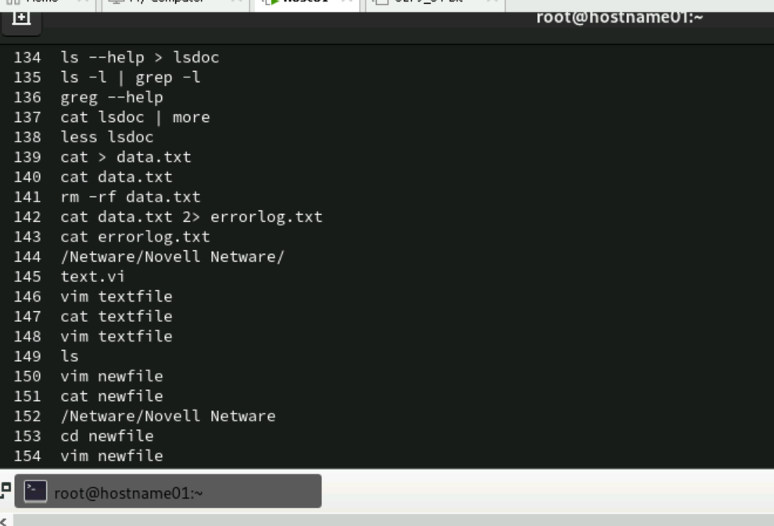

4: Search ls command in history file

Ans. history | grep ls

5: Repeat the last command rd

6: Execute 3 command from history file.

Ans . less lsdoc

7: What are the different shells available.

**Ans : cat /etc/shells**

Understanding access permissions

7.1: Create an empty file “demofile” and perform following instruction

1. Revoke read permission from owner and use cat command.

2. Revoke write permission from owner and open using vi

editor and add some contain in it.

3. Add read and write permission to owner.

4. Revoke write and execute from other and group

Ans :chmod u+rw demofile

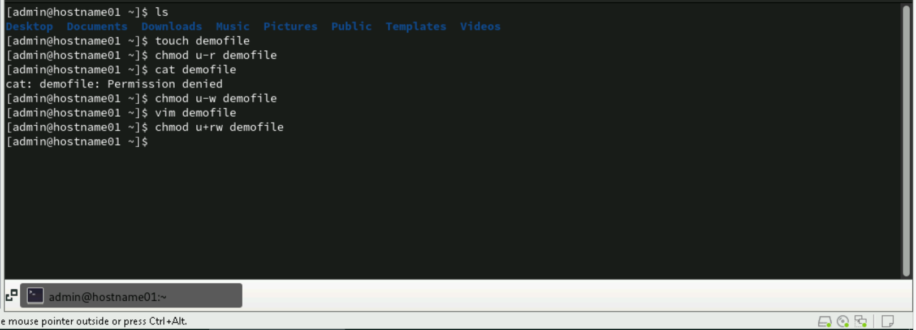

5. Add write permission to group only

Ans :chmod u+rw demofile

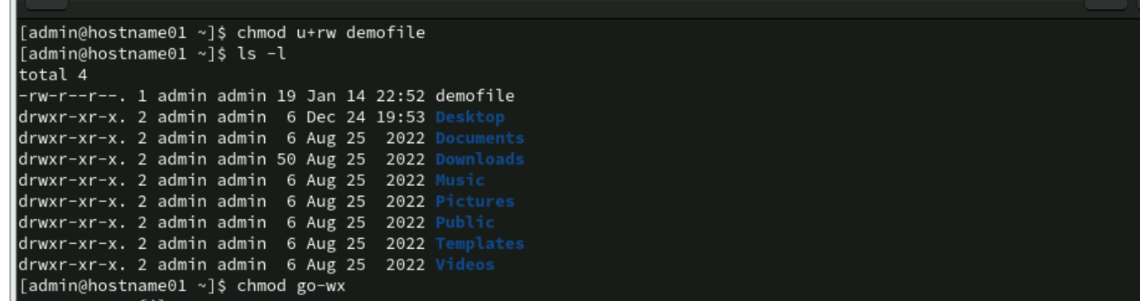

6. Assign read permission to all

Ans :chmod go-wx

7. Revoke read permission from others

Answer:chmod a+r demofile

8. Give the execute permission for the user for a file chap1

Ans: chmod u+x chap1

9. Give the execute permission for user, group and others for a file add.c

Ans. chmod a+x add.c

10. Remove the execute permission from user, give read permission to

group and others for a file aa.c

Ans. chmod u-x,go+r aa.c

11. Give execute permission for users for a.c, kk.c, nato and myfile using

single command

Ans. chmod u+x a.c kk.c nato myfile

7.2: Create an directory “demo” and copy /etc/passwd file in it

1. Display contents of demo **Ans: ls demo**

2. Revoke read permission from demo directory and use ls command on it

**Ans.** **chmod -r demo**

**ls demo**

3. Revoke write permission from demo directory and try to copy

/etc/profile file in it

**Ans.** **chmod -w demo**

**cp /etc/profile demo/**

4. Delete passwd file from demo directory

**rm demo/passwd**

5. Revoke execute permission from demo directory and try cd command on demo.

**chmod -x demo**

**cd demo**

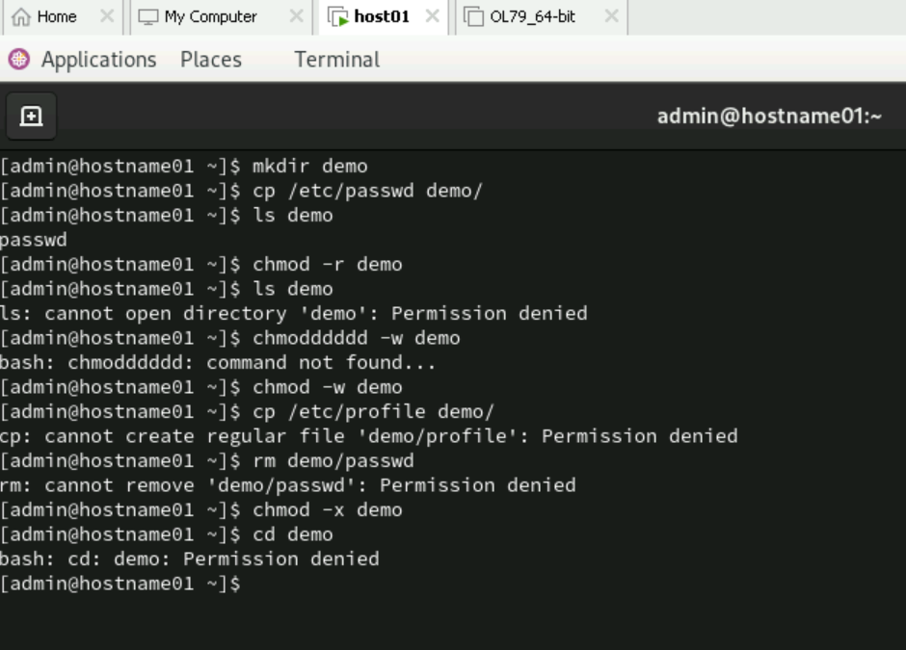

**Using Process-Related Commands**

1. Find out the PID of the processes that are activated by you

1. Find out the information about all the processes that are currently active

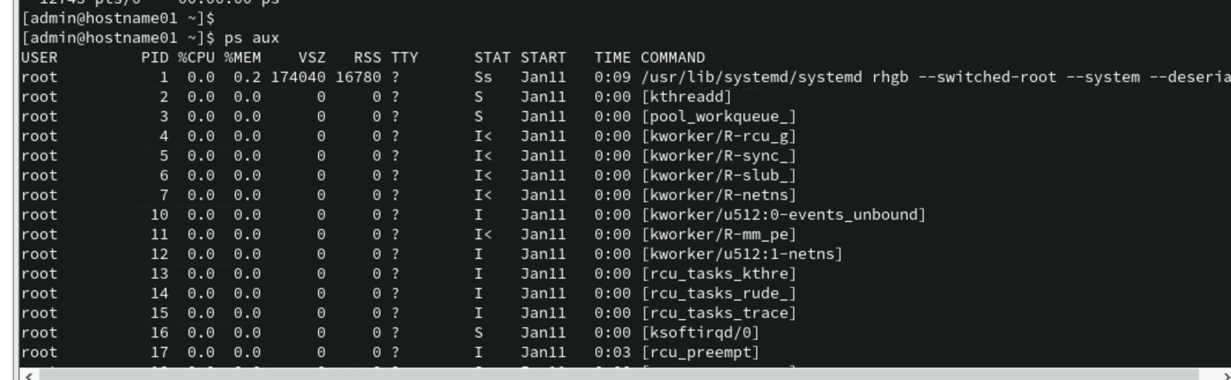

3. Start a different process in the background. Find out the status of the background

process using the PID of the same.

1. Run a job in background

1. Bring a last background job in fore ground

1. Run 3 jobs in background and bring first job in foreground

1. Stop current job

1. Start stopped job

1. Run a job

Sleep 300 (In Foreground)

Sleep 300& (In Background)

11. Kill your shell using process id

**Ans.1. Find the pid:echo $$**

**Ans.2.kill the shell :kill-9 pid**

12. Execute a ls command by setting priority as -10 using nice command

**Ans .sudo nice -n -10 ls**

13. Display a date on every hour using cron tab

